**Title: Use Autopsy to recover file from the given data source. Present your details accordingly**

**Objective:**

The objective of this experiment is to utilize Autopsy, a digital forensics tool, to recover a file from a specific data source.

**Requirements:**

* Autopsy software installed
* Data source containing the target file for recovery (e.g., a storage device, disk image, or forensic image)

**Procedure/Experiment Steps:**

1. Launch Autopsy: Open the Autopsy software on your computer.

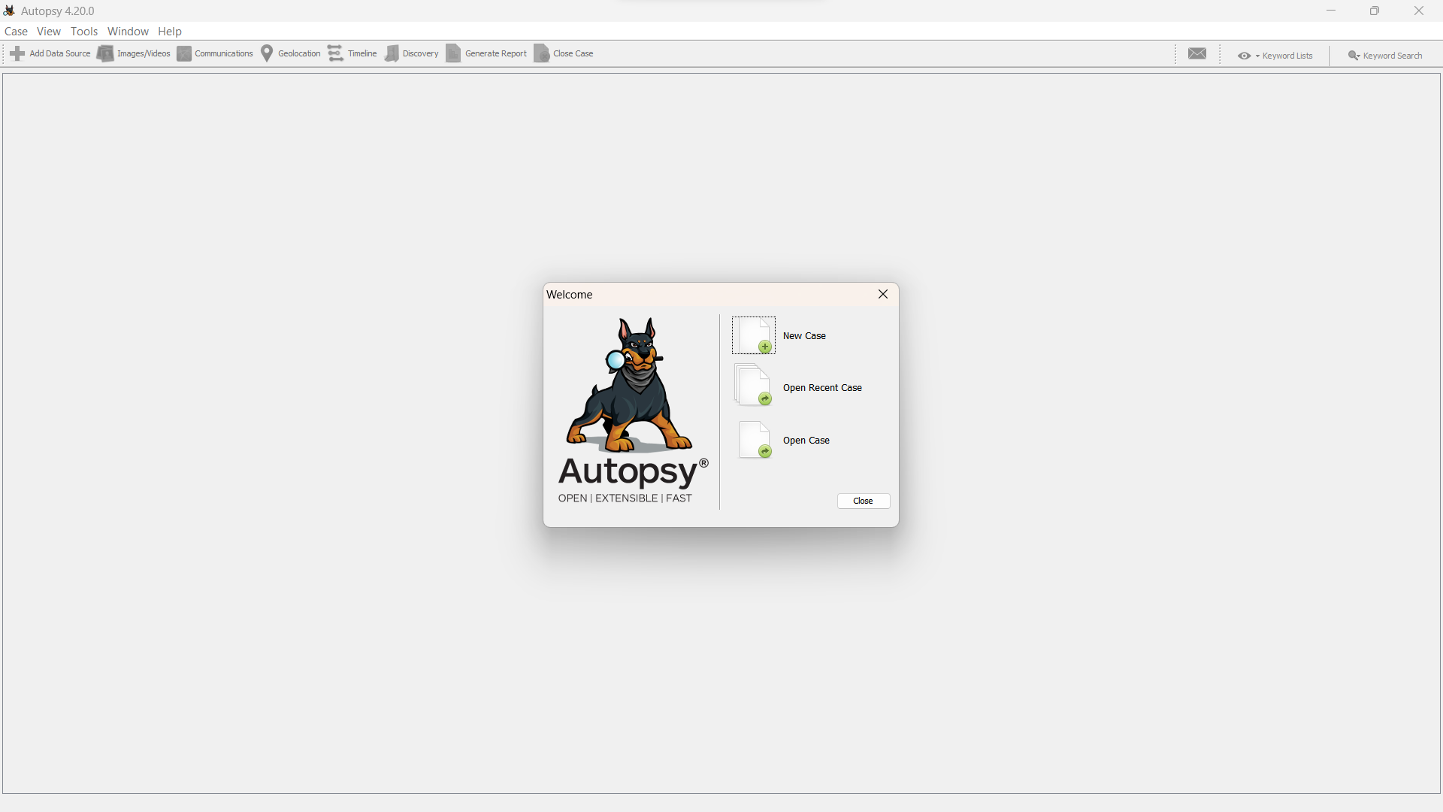

1. Create a New Case: Create a new case within Autopsy to organize your investigation.

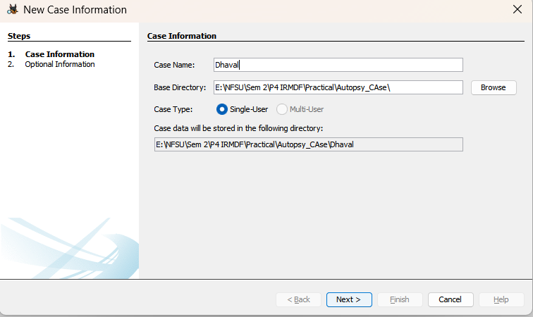

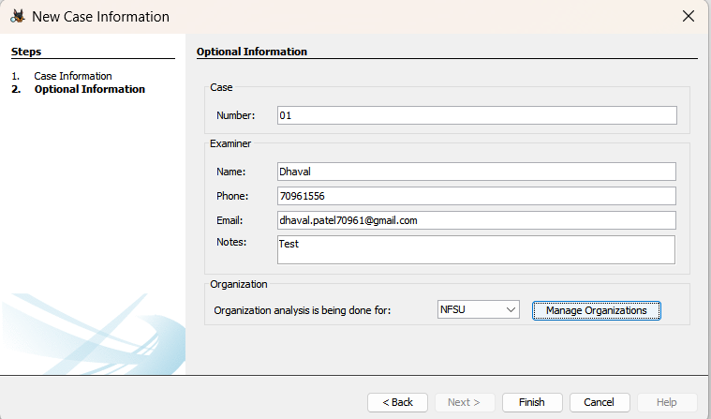

1. Add Data Source: Import the given data source, which contains the target file, into the Autopsy case. This can be done by selecting the "Add Image" or "Add Device" option, depending on the nature of the data source.

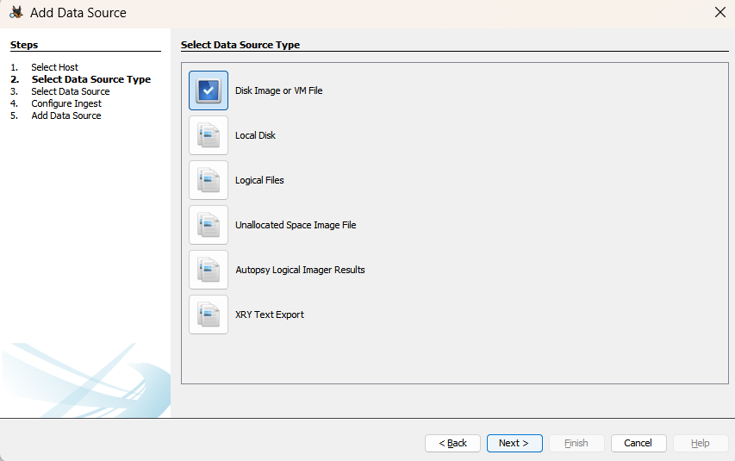

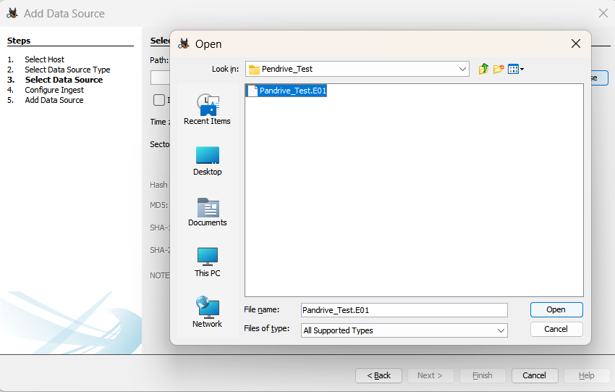

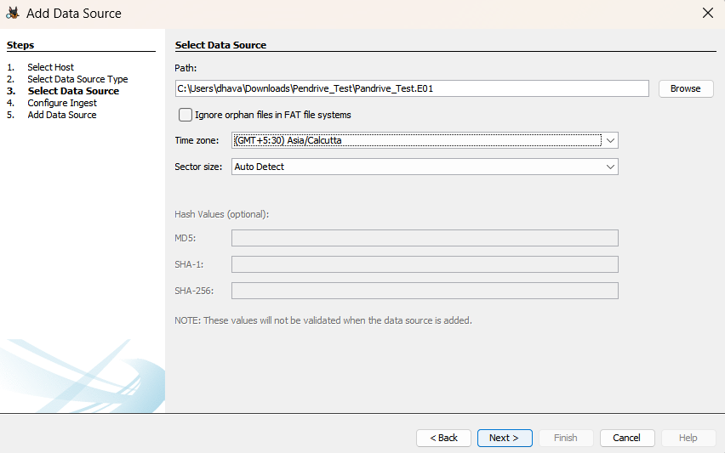

1. Configure Data Source: Provide necessary information about the data source, such as the image file or device details, during the configuration process.

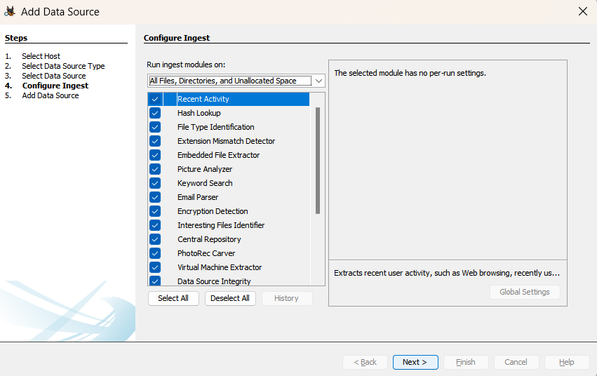

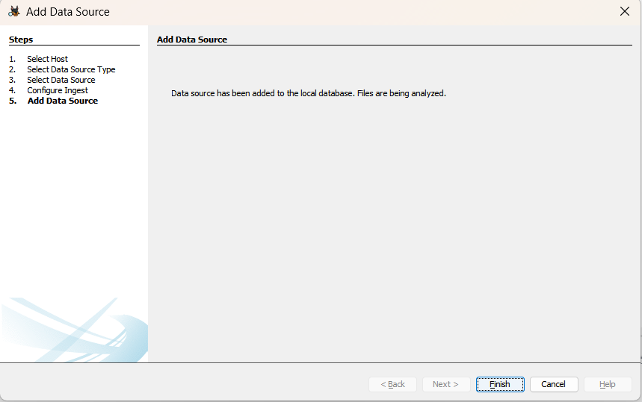

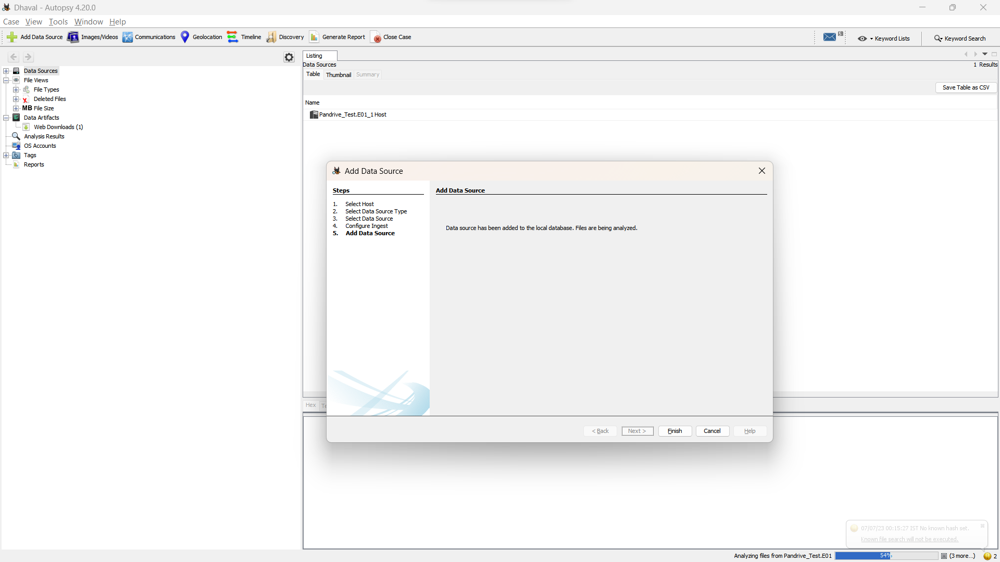

1. Start Analysis: Once the data source is added and configured, initiate the analysis process within Autopsy.

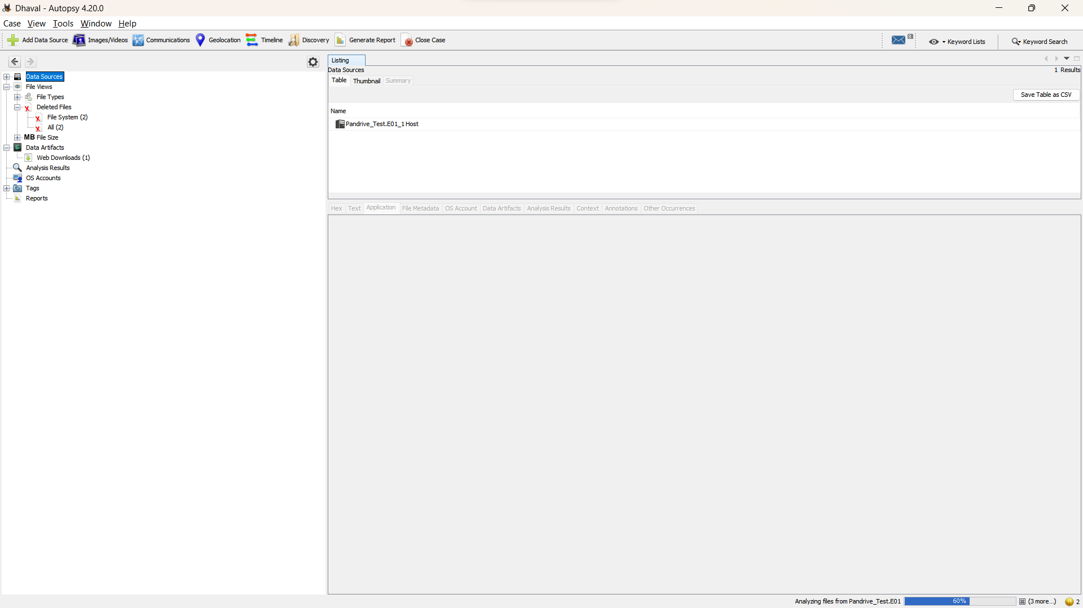

1. Search for File: Utilize Autopsy's search functionality to locate the target file within the data source. You can specify the file name or use file metadata to narrow down the search results.

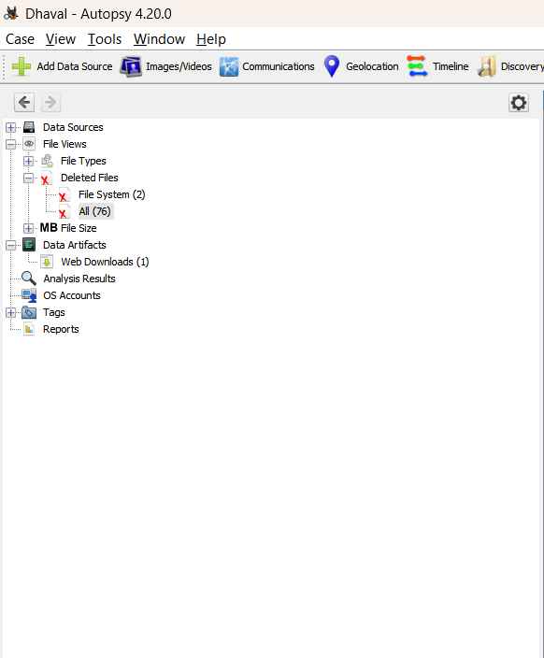

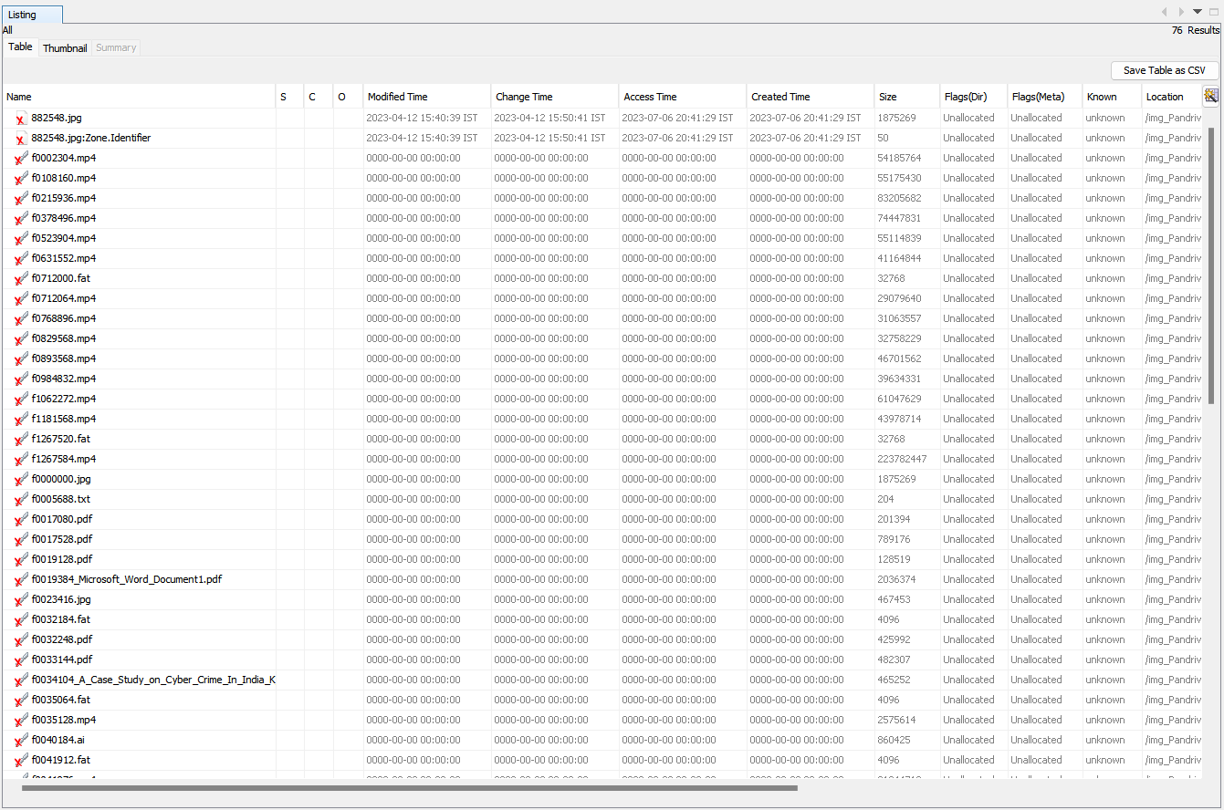

1. Recover File: Once the target file is located, select the file and choose the recovery option provided by Autopsy. Follow the prompts to specify the destination for the recovered file.

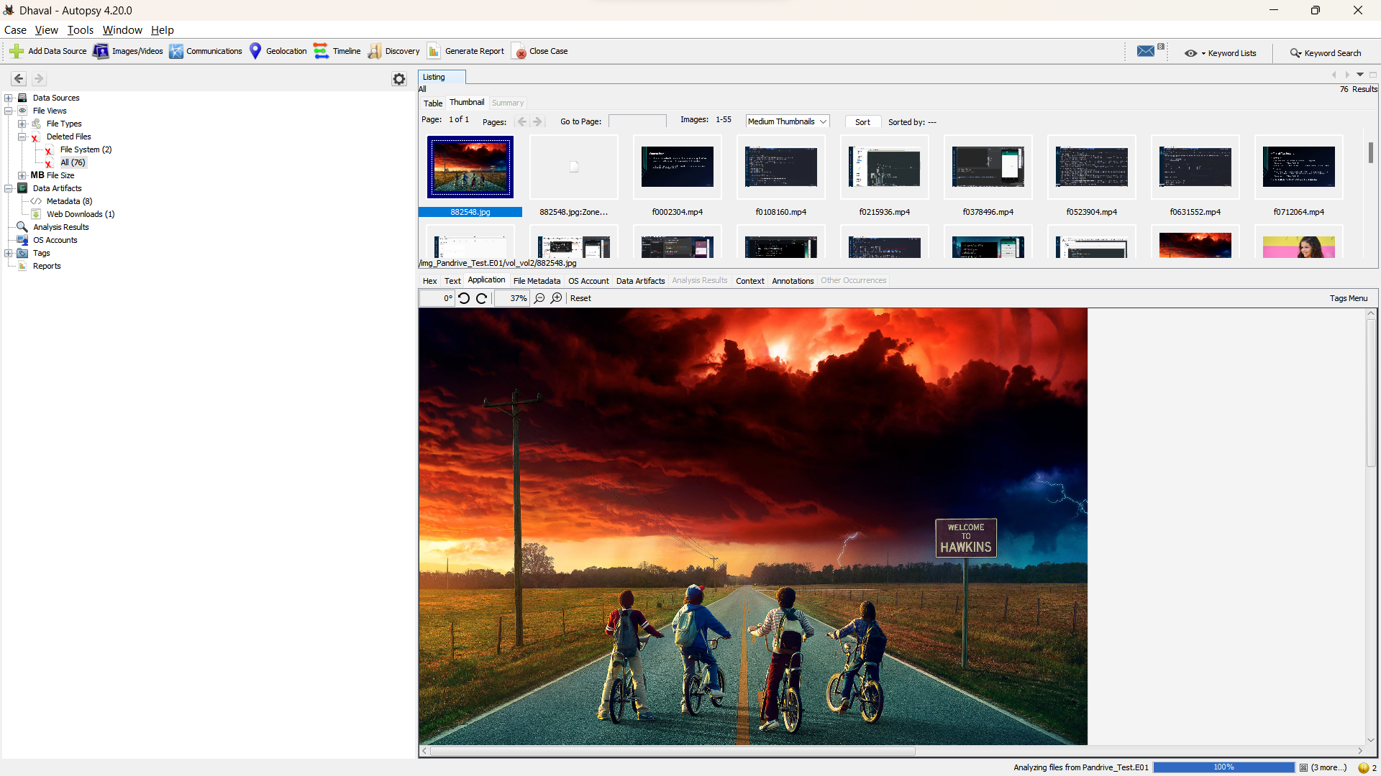

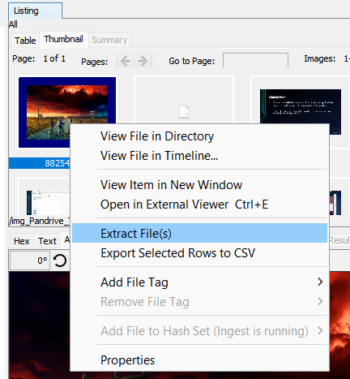

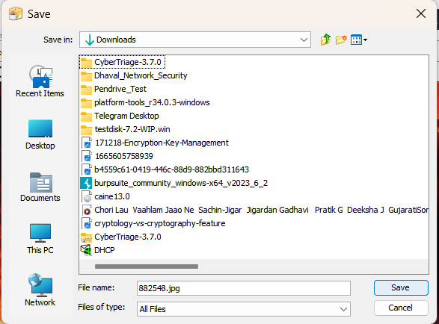

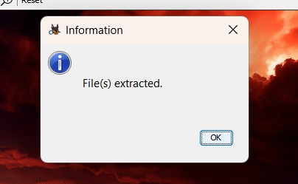

1. Verify Recovery: After the recovery process is complete, verify the recovered file's integrity and accessibility to ensure a successful recovery.
2. Document Findings: Record the details of the recovery process, including the file name, location, and any additional observations or notes.

**Result:**

Using Autopsy, we successfully recovered the target file from the given data source. After adding and configuring the data source within the Autopsy case, we initiated the analysis and performed a search to locate the file. The file was successfully recovered, and its integrity and accessibility were verified. The details of the recovery, including the file name, location, and any relevant observations, were documented for further analysis.

**Conclusion:**

Autopsy proved to be an effective digital forensics tool for file recovery from the given data source. Its comprehensive search capabilities, combined with the recovery functionality, allowed us to successfully locate and recover the target file. Autopsy can be a valuable asset in forensic investigations, data recovery processes, and digital evidence analysis.

**Future Scope:**

1. Advanced file carving techniques: Explore Autopsy's advanced file carving capabilities to recover files even in fragmented or damaged states.
2. Timeline analysis: Utilize Autopsy's timeline feature to establish a chronological order of events related to the recovered file and other artifacts.
3. Metadata extraction and analysis: Extract and analyze file metadata using Autopsy to gain further insights into the recovered file's origin, timestamps, and associated attributes.
4. Hash analysis: Perform hash analysis on the recovered file to determine its integrity and check against known hash databases for potential matches.
5. Integration with other forensic tools: Explore integrating Autopsy with other digital forensics tools for a more comprehensive analysis and cross-validation of findings.